POWER BRUSHING

Q How do electric toothbrushes work?

A The brush of an electric toothbrush has rotating tufts or a vibrating head which provides a lot of the action needed for thorough cleaning.

Q Do electric brushes clean better?

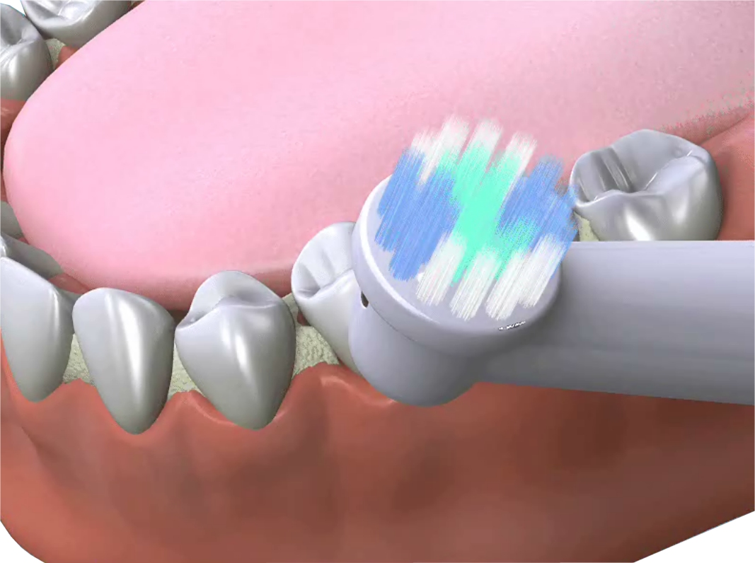

A Tests and clinical trials have shown that certain electric toothbrushes are better than manual brushes at removing the primary cause of dental decay and gum disease, i.e. dental plaque.

Q Why are electric toothbrushes better at removing dental plaque?

A With very little movement from the user there is a great deal of active cleaning movement of the bristles against the teeth. They are particularly useful for people with limited movement, such as disabled or elderly people who often find that using a normal toothbrush does not allow them to clean thoroughly.

Q How do they do this?

A There are different ways that the design of the toothbrush provides the necessary action to the bristles. One way is to make the individual tufts rotate, or arrange the tufts around a circular head which rotates or even make the bristles vibrate.

Q What is the benefit of having rotating or oscillating tufts?

A When there are single tufts which are individually oscillating back and forth many times a minute the bristles are flexible enough to allow better penetration between teeth and so clean areas often missed with a manual toothbrush.

Alternatively a round head with a ring of tufts placed around the perimeter moving back and forth (like the Braun/Oral-B or Philips) works well doing the same thing in a slightly different way.

Laboratory tests have shown that sonic vibrations (as in the Sonicare) are also detrimental to plaque.

Q Are electric toothbrushes suitable for children?

A Electric toothbrushes can be better for children as they may be more inclined to brush regularly because of the novelty of using an electric toothbrush. Discuss the idea with your dentist or hygienist to find out if your child would benefit from using an electric toothbrush.

Q What sort of toothpaste should I use?

A To have a clean and healthy mouth you need to use the correct dental care products. Ask your dentist or hygienist to tell you what is best for you. Some toothpastes come in a gel form and are ideal for electric brushes. Alternatively using a regular requires running the head under the tap for 15 seconds after use – to prevent the mechanism from becoming clogged with dried abrasive.

As well as regular family toothpastes, there are many specialist toothpastes. These include tartar control for people who are prone to tartar build-up and desensitising ingredients those with sensitive teeth. Total care toothpastes include substances to help fight gum disease, freshen breath and help reduce plaque build-up.

Q Can I use a whitening toothpaste?

A Whitening, baking soda or smokers’ toothpastes are not recommended for use with electric toothbrushes because of their additional abrasive ingredients.

Whitening toothpastes are good at removing stains but are not strong enough to change the natural shade of the teeth.

Q Should I use a fluoride toothpaste?

A Yes, fluoride helps to strengthen and protect teeth which can reduce tooth decay in adults and children.

Children’s toothpastes have about half the level of fluoride that adult toothpastes have. They still provide extra protection for the teeth but as children have a tendency to eat their toothpaste, there is less risk of them taking too much fluoride.

Q How much toothpaste should I use?

A You do not need to smother the head of your brush in toothpaste. Wet the brush head and apply only a pea-sized amount. This is quite enough. Children should use a small scraping of toothpaste.

Q Can I use an electric toothbrush if I have had periodontal surgery?

A Discuss with your dentist or hygienist who has examined your mouth. Usually an electric brush will improve your plaque control and so help restore your gums to a healthy condition.

Q How do I use the electric toothbrush?

A Apply the toothpaste as described above. Insert the brush into your mouth before switching it on. Place the brush head with the bristles on the surface of the teeth and angled about 45° towards the gum margin. Move slowly from tooth to tooth, being sure to brush especially in between, until all surfaces of teeth have been covered.

Q Do I still have to scrub?

A No. The brush head automatically provides the correct cleaning action.

Q What damage will I cause if I press to hard?

A If excessive pressure is applied the unit will slow down or even stop.

Q How long should I brush for?

A Most recommendations say two minutes but thoroughness is more important than time. Units often have a built-in timer which switches off after two minutes.
Remember to switch off before taking the brush from your mouth to avoid splashing.

Q My gums bleed slightly after I use the electric brush.

A If this is a new method of oral hygiene for you, the slight bleeding at first may be normal but should stop within a few days. If it continues for more than a couple of weeks then consult your dentist.

Q How should I look after my electric toothbrush?

A Always rinse the brush thoroughly after each use since toothpaste inside the mechanism may prevent the brush from working properly. Fifteen seconds under a running tap should be sufficient.

A Twenty four hours

Q How often should I completely recharge a unit with rechargeable batteries?

A Follow the manufacturer’s instructions. Normally rechargeable batteries need a 24 hour charge before the first use, after which EITHER use the toothbrush normally until fully discharged, then recharge for 12 to 16 hours OR replace it on the charger base after each use.

The Unit should be run down completely and recharged for a full 24 hours once every three months.

Q How often should I replace the brush head?

A Every three months should be sufficient.

